ESSER - A Traditional Brand Celebrates its 40th Anniversary

Neuss, October 22, 2013 - ESSER, one of the most well-known brands for professional fire alarm systems, observes 40 years of successful history.

Since the company's founding in 1973 by Klaus Esser, who was awarded the first-ever German Marketing Award, the company has continuously changed until this day, and has always made the necessary adjustments to changing market conditions so as to focus on customer needs - one of his recipes for success.

In addition to fire detection technology, the brand has also established itself in the security technology areas of voice alarms and risk management. A clear trend towards integration of communication among various building systems has emerged in the past several years. The Internet will play a primary role in this context of standardization. In view of the above, the Honeywell Corporation, to which the ESSER brand has belonged since 2005, is in an excellent position due to its size, global presence and its technology base.

Bernd Heinen , who as Executive Director of the ESSER-Zeit, was able to witness in all its facets, comments on this, "The success story would be incomplete without mentioning the decades of support from our business partners at home and abroad who have made our success possible. I offer my special thanks as well to all the people who, as part of the company, have contributed and helped to shape it, as well as offering all of their energy to its service."

Telephone contact: Manuel Pelazas, International Sales Support +49 (0) 2131 / 40615479

Illustration:
ESSER - a success story in 40 milestones

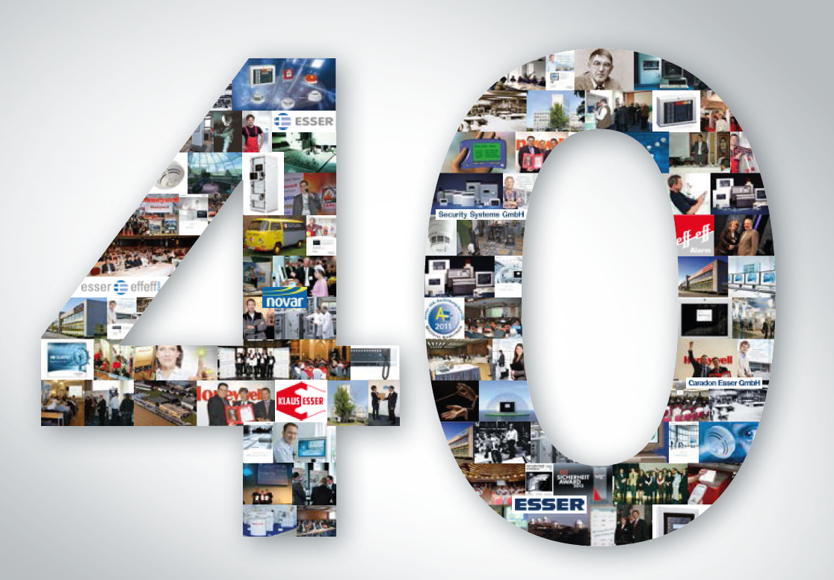
Novar GmbH is part of the Honeywell Life Safety business unit (HLS) and is highly regarded, with its long-established ESSER and Ackermann brands, as a leader in the field of fire detection technology, voice alarm and in the hospital and care communication.

HLS, with sales of 15.9 billion U.S. dollars, belongs to Automation and Control Solutions (ACS), one of four strategic business units within the Honeywell Group. HLS provides worldwide protection with its innovative products, people and assets, and is a leader in fire protection, communication systems, gas detection, and personal protective equipment, as well as in patient monitoring. The high quality products, integrated system solutions and services make life safer and more comfortable. HLS leading-edge technology is found everywhere in your immediate vicinity - in products, software and system solutions, such as in airports, hotels, hospitals, schools, business centers, and stadiums, as well as in industrial environments.

Honeywell International is a diversified Fortune 100 company serving customers worldwide with aerospace products and services, control technologies for buildings (private and commercial), products for the automotive industry, and turbochargers as well as specialty materials. Honeywell operates within the EMEA region (Europe, Middle East and Africa) EMEA in over 35 countries and employs some 30,000 people there. Honeywell's shares are traded in the stock markets of New York, London and Chicago. For more information, please visit www.honeywellnow.com.

This release contains forward-looking statements as defined in Section 21E
of the Securities Exchange Act of 1934, including statements
about future business operations, financial performance and market conditions. Such forward-looking statements involve risks and uncertainties inherent in business forecasts as further described in our filings under the Securities Exchange Act.

