**The ESSER FlexES can now be operated remotely**

Neuss, September 14, 2012. The recently introduced FlexES control remote operating unit is based on the latest generation of touch panels and is a convenient solution for decentralized access to the ESSER fire alarm control panel (FACP). This innovative device is also ideally suited to controlling a network, so all operating processes and conditions on an essernet® with multiple FACPs can be managed from one point.

Similar in design to the FlexES control, the user interface is quick and intuitive to operate. The 16:9 widescreen touch panel with its black polished aluminum frame has WVGA resolution. Different levels of access managed by corresponding authorization codes enable hierarchical control based on user rights. The remote operating unit can be used at distances of up to 1000 meters from the fire alarm control panel. This ensures great flexibility in the distribution of information relevant to operation and notification on the premises. It can be mounted on or flush with any suitable surface. Languages available for the user interface are German, English, Russian and French. The language can be switched during operation. Additional languages will be available soon.

1,235 characters (incl. spaces)

**Contact:** Joachim Meisehen, Marketing/Communications +49 (0) 21 37/17-226

http://www.esser-systems.com/en/press.html

Image:

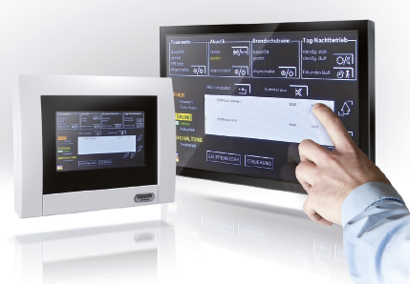

BU: Remote display and operating panel for the FlexES fire detection system

*Rich in tradition, the Ackermann and ESSER brands make Novar GmbH, part of the Honeywell Group, a market leader in the area of fire detection technology, voice alarm systems as well as in hospital and health care communication.*

*Honeywell International (*[*www.honeywell.com*](http://www.honeywell.com/)*) is a diversified Fortune 100 company that* *leads**the field in the areas of technology and production. Honeywell supplies customers across the globe with aeronautical products and services, building control technology (private and commercial), products for the automobile industry, turbo chargers and**special materials. Honeywell operates within the EMEA region (Europe, the Middle East and Africa) in over 35 countries and has around 30 000 employees there. Honeywell shares are traded on the New York, London and Chicago stock exchanges. For further information see* [*www.honeywellnow.com*](http://www.honeywellnow.com/)*.*

*This publication contains anticipatory statements according to the definition in section 21E   
of the Securities Exchange Act (Wertpapierbörsengesetz) of 1934, including information   
on future business processes, financial results and market conditions. Such anticipatory statements contain the risks usual for business predictions and uncertainties as described in more detail in the documents according to the Securities Exchange Acts.*